IT RCSA Audit Documentation
Config Authentication – BSI.IT.10.C13
Design Assessment, Walkthrough and Sample of One (MIA-DC-PRINT1 – Windows / mia-dc-nb01-fs – Linux)
DESIGN RATING | SAMPLE | OBSERVATIONS
SATISFACTORY | MIA-DC-PRINT1  mia-dc-nb01-fs  FAIL (lockout duration) | 3

Control | BSI.IT.10.C13 – Config Authentication (Key, Semi-Automated, In every operation)
Review period | 07/05/2025 – 01/04/2026 (Semi-Annual); evidence captured 11/03/2026
Open Action Driver | 005056BCA24E1FD0B4A6A1173BF00BA4 – 2025 RCSA C13 exceptions, target 09/30/2026, still open. Per RCSA Testing Procedure sec. 4.1.3 this is remediation testing, not CDA / CPA.
Walkthrough | IT RCSA (Edward Morfa) met with Ian Rojo (control owner) and [Infrastructure participants – to be confirmed] on [walkthrough date - to be confirmed]
Sample of one | MIA-DC-PRINT1 (Windows, image / GPO) and mia-dc-nb01-fs (RHEL, manual build) – both part of the 2025 exception
Evidence folder | CDA/C13_CDA_Evidence and CPA/C13_CPA_Evidence. Start with BSI.IT.10.C13_E00_Evidence Index.xlsx.

Control description
[BSI.IT.10.C13 Config Authentication] In every operation, Infrastructure Engineering have configured strong authentication settings/policies for operating systems on premise to align with the Authentication and Authorization Standard. Exception to authentication configurations must be approved by the CISO.

How to use this document
All files sit in this control's CDA and CPA folders, named by E-number (for example C11_CPA_Evidence / E02). The E00 Evidence Index lists every file with its MD5. Each result in Section 3 names its evidence and where to look. Section 4 lists every place the sample appears. Results read: Pass (green), Fail (red), Observation / Open (amber - not an exception).

Evidence References
Ref | Evidence | Used for
CDA E01 | Authentication and Authorization Standard v13.0 (07/28/2026) | Named in the control; no server values (SUS.AAS.4.2.1.4 p.7 is for workstations)
CDA E02 | Windows Server Hardening Guide v6.0 (09/17/2026) | Sec. 4.2 Account Lockout Policy; 2.3.7.3 inactivity limit
CDA E03 | Linux RHEL Hardening Guide v1.5 | Items 82–90, 4.4.3.x (p.15–16): deny 5, unlock_time 900, minlen 14, maxrepeat 3, remember 24
CDA E04 | Secure Build and Configuration Management Standard v8.0 | SUS.SBS.4.2.1.5, 4.2.1.6 (p.6)
CDA E05 | 2025 Exception form | 2025 exceptions under the AD
CPA E01 | Windows security exports (10) | security_exportMIA-DC-PRINT1.txt
CPA E02 | Linux pwquality captures 11/03/2026 | mia-dc-nb01-fs – 1st screenshot
CPA E03 | SEF exceptions 07/01/2025 – 07/04/2026 | Blank file

1. Design Effectiveness Summary
The control design is effective. Trigger: every server build. Windows password and lockout policy come from the image and domain GPO and are re-applied at each policy refresh (CDA E02). Linux pwquality, faillock, pwhistory and login.defs values are set by the Linux admin during the build (CDA E03). InfoSec scans servers at least quarterly and any deviation needs a CISO-approved SEF exception (CDA E04, SUS.SBS.4.2.1.5–4.2.1.6).
Overall Rating: Satisfactory, with observations: (1) the control statement names the Authentication and Authorization Standard, but the server values are in the hardening guides; (2) escalation is not working for the 2025 finding – the AD is past its 09/30/2026 target, the Windows lockout duration is unchanged and there is no CISO exception; (3) the Linux evidence request needs to cover every setting. Per sec. 4.1.3 the rating is held in HERACLES until the AD closes.

2. WT Summary
IT RCSA met with Ian Rojo (control owner) and [Infrastructure participants – to be confirmed] on [walkthrough date - to be confirmed]. The owner confirmed the process is unchanged from the 06/06/2025 walkthrough.
- Windows: password policy (length 14, complexity, age 1 / 45, history 24) and lockout policy (5 attempts, duration, reset counter) are pushed by GPO; inactivity limit 900 seconds.
- Linux: pam_pwquality (minlen 14, dcredit / ucredit / lcredit / ocredit -1, maxrepeat 3), pam_faillock (deny 5, unlock_time 900), pam_pwhistory (remember 24) and login.defs are set at build.
- Deviation: needs a SEF exception approved by the CISO.
- 2025 finding: Windows lockout duration -1 and idle timeout; Linux maxrepeat 0. AD due 09/30/2026.
Sample of one: MIA-DC-PRINT1 and mia-dc-nb01-fs were checked against the guides. Results are in Section 3.
Based on the walkthrough, the control appears to be designed appropriately. For the sample, the Windows inactivity timeout is now fixed, but the account lockout duration is still -1 and no CISO exception exists, so the Windows item fails. The Linux item can't be concluded because maxrepeat was not provided.

3. Sample of One – MIA-DC-PRINT1 (Windows) and mia-dc-nb01-fs (Linux)
Workpaper column | Value / conclusion | Evidence reference | Result
Minimum password length (guide 14) | MinimumPasswordLength = 14 | CPA E01 PRINT1, [System Access] | Pass
Complexity (guide Enabled) | PasswordComplexity = 1 | CPA E01 | Pass
Minimum / maximum age (guide 1 / 45) | 1 / 45 | CPA E01 | Pass
History (guide 24) | PasswordHistorySize = 24 | CPA E01 | Pass
Lockout threshold (guide 5) | LockoutBadCount = 5 | CPA E01; CDA E02 sec. 4.2 | Pass
Reset lockout counter (guide 1440 s) | ResetLockoutCount = 30 minutes (stricter) | CPA E01; CDA E02 sec. 4.2 | Pass
Account lockout duration (guide 15 min) | LockoutDuration = -1 (locked until admin unlocks) – same as 2025 | CPA E01; CDA E02 sec. 4.2 | Fail
Inactivity limit (guide 900 s or less, not 0) | InactivityTimeoutSecs = 900 – 2025 issue fixed | CPA E01; CDA E02 2.3.7.3 | Pass
Linux complexity credits (guide -1) | mia-dc-nb01-fs: dcredit / ucredit / lcredit / ocredit = -1 (11/03/2026 12:03 PM) | CPA E02, screenshot 1 | Pass
Linux maxrepeat (guide 3) – 2025 exception | Not provided | CPA E02 | Open
Linux minlen, remember, deny, unlock_time | Not provided | CPA E02 | Open
"Exception ... approved by the CISO" | No SEF exception for lockout duration; SEF export blank | CPA E03 | Fail
Action Driver follow-up | Target 09/30/2026 passed; no extension or escalation seen | CDA E05 | Fail
Conclusion: Sample MIA-DC-PRINT1 FAILED – account lockout duration is still -1 against the guide's 15 minutes, with no CISO-approved exception. The 2025 inactivity timeout issue is fixed. Sample mia-dc-nb01-fs is INCOMPLETE – the credit settings meet the guide but maxrepeat (the 2025 exception) was not provided. The AD should stay open.

4. Evidence Locator – where to find the samples
Ref | Evidence | What it shows
CDA E02 | Windows Server Hardening Guide v6.0 – sec. 4.2, 2.3.7.3 | Lockout duration 15; inactivity 900 s
CDA E03 | Linux RHEL Hardening Guide v1.5 – items 82–90 (p.15–16) | Linux values incl. maxrepeat 3
CDA E05 | 2025 Exception form | Original 2025 exceptions
CPA E01 | security_exportMIA-DC-PRINT1.txt – [System Access] and registry lines | Settings (Exhibit A1)
CPA E02 | C13 Linux-evidenceNov2026 – screenshot 1 | mia-dc-nb01-fs credits (Exhibit A2)
CPA E03 | SEF export | Blank
WP2 | WP2 BSI.IT.10.C13 Config Authentication 2026.xlsm – CPA tab row 51 and row 73 | Same results in workpaper form

Appendix A – Sample Evidence
Exhibit A1: MIA-DC-PRINT1 security export – excerpt (CPA E01)
MinimumPasswordAge = 1
MaximumPasswordAge = 45
MinimumPasswordLength = 14
PasswordComplexity = 1
PasswordHistorySize = 24
LockoutBadCount = 5
ResetLockoutCount = 30
LockoutDuration = -1
MACHINE\Software\Microsoft\Windows\CurrentVersion\Policies\System\InactivityTimeoutSecs=4,900
Source: CPA E01 – security_exportMIA-DC-PRINT1.txt (secedit /export /cfg). LockoutDuration = -1 is the failing value.
Exhibit A2: mia-dc-nb01-fs – pwquality credit settings (CPA E02)
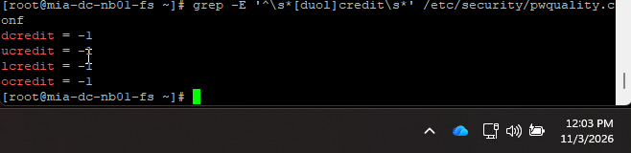
Source: CPA E02 – C13 Linux-evidenceNov2026.docx, screenshot 1. Screen clock 11/03/2026 12:03 PM. maxrepeat is not shown.
Exhibit A3: Other Linux captures received (CPA E02)
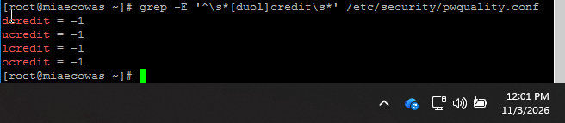
Figure A3-1. miaecowas – credit settings only (11/03/2026).
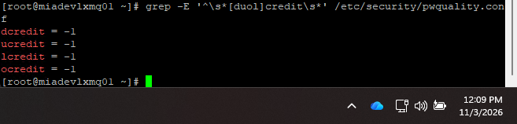
Figure A3-2. miadevlxmq01 – credit settings only (11/03/2026).
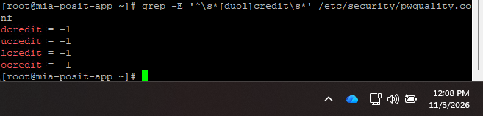
Figure A3-3. mia-posit-app – credit settings only (11/03/2026).
Package: CDA and CPA evidence folders, E00 index, WP2 2026 workbook and this document.

